# What's OVER Here: Using RANK Function for League Rankings

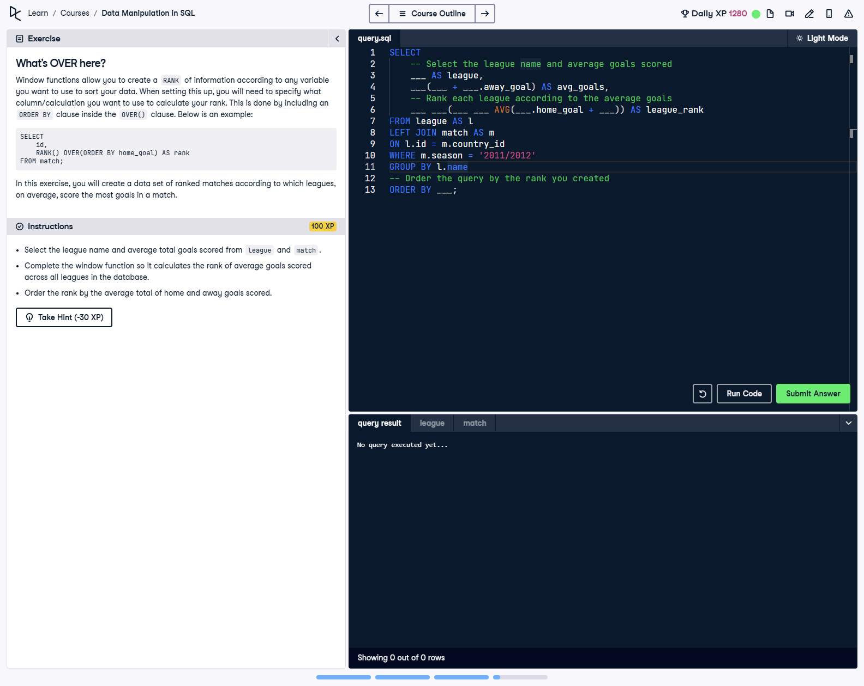

## Question

Select the league name and average total goals scored from the league and match tables. Complete the window function so it calculates the rank of average goals scored across all leagues in the database. Order the rank by the average total of home and away goals scored.

## Corrected Solution

SELECT  
 -- Select the league name and average goals scored  
 l.name AS league,  
 AVG(m.home_goal + m.away_goal) AS avg_goals,  
 -- Rank each league according to the average goals (lowest to highest)  
 RANK() OVER(ORDER BY AVG(m.home_goal + m.away_goal)) AS league_rank  
FROM league AS l  
LEFT JOIN match AS m  
ON l.id = m.country_id  
WHERE m.season = '2011/2012'  
GROUP BY l.name  
-- Order the query by the rank you created  
ORDER BY league_rank;

## Explanation

This query ranks leagues based on the average total goals scored during the 2011/2012 season. The RANK() function uses a window function with an ORDER BY clause in ascending order to rank leagues from the lowest to the highest average goals. The AVG() function calculates the average of home and away goals for each league, grouped by league name. Finally, the results are ordered by the calculated rank.